

SIMATS SCHOOL OF ENGINEERING
SAVEETHA INSTITUTE OF MEDICAL AND TECHNICAL SCIENCES
CHENNAI-602105

ASSESSMENT 1
CSA1006-SOFTWARE ENGINEERING
Problem 1: Applying Scrum in a Telemedicine App Project
Scenario
A company is developing a Telemedicine Mobile App that allows patients to book appointments, consult doctors online, access medical records, and receive digital prescriptions. During development, the Product Owner frequently changes the Product Backlog during Sprint Planning, causing confusion among the Scrum Team. As a result, sprint goals are not achieved, team productivity decreases, and stakeholders become dissatisfied.
1. Scrum Roles and Responsibilities
a) Product Owner (PO)
- Defines the product vision and business goals.
- Creates and prioritizes the Product Backlog.
- Clarifies requirements for the development team.
- Accepts or rejects completed work.
- Should avoid changing sprint requirements once a sprint has started.
b) Scrum Master
- Ensures Scrum practices are followed.
- Removes obstacles affecting the team.
- Facilitates Sprint Planning, Daily Scrum, Sprint Review, and Retrospective.
- Helps improve communication between stakeholders and the Scrum Team.
c) Development Team
- Designs, develops, tests, and delivers working software.
- Estimates effort for backlog items.
- Completes the Sprint Goal within the sprint duration.
- Collaborates with the Product Owner to understand requirements.
2. Root Cause Analysis
Problems Identified
- Frequent Requirement Changes
  - The Product Owner keeps modifying backlog items during Sprint Planning.
- Poor Backlog Grooming
  - User stories are not properly refined before the sprint.
- Lack of Stakeholder Alignment
  - Stakeholders continuously introduce new requirements.
- Reduced Productivity
  - Developers spend time adjusting to changing priorities instead of completing planned work.
- Sprint Goal Failure
  - Constant backlog changes prevent the team from finishing committed tasks.
Example
If the team starts developing the Online Appointment Booking feature and the Product Owner suddenly changes the priority to Video Consultation, the developers must stop their current work, causing delays and confusion.
3. Improved Backlog Prioritization Plan
The company should follow a structured backlog prioritization process.
a) Prioritize Using MoSCoW Method
- Must Have
  - User Registration
  - Appointment Booking
  - Video Consultation
- Should Have
  - Digital Prescription
  - Medical Records
- Could Have
  - Health Tips
  - Appointment Reminders
- Won't Have (Current Sprint)
  - AI Health Chatbot
  - Wearable Device Integration
b) Freeze Sprint Backlog
- Finalize backlog items before Sprint Planning.
- Avoid changing sprint requirements after the sprint begins.
c) Regular Backlog Refinement
- Conduct backlog grooming sessions before every sprint.
- Ensure all user stories are complete and clearly defined.
d) Stakeholder Communication
- Gather all stakeholder feedback before Sprint Planning.
- Reduce last-minute requirement changes.
4. Retrospective Improvement Suggestions
During the Sprint Retrospective, the Scrum Team should:
- Improve backlog refinement before Sprint Planning.
- Define clear acceptance criteria for every user story.
- Limit backlog changes during active sprints.
- Encourage better communication between stakeholders and developers.
- Review sprint performance and identify improvement areas.
- Estimate tasks more accurately for future sprints.
- Conduct regular sprint reviews to collect feedback.

BLOCK DIAGRAM
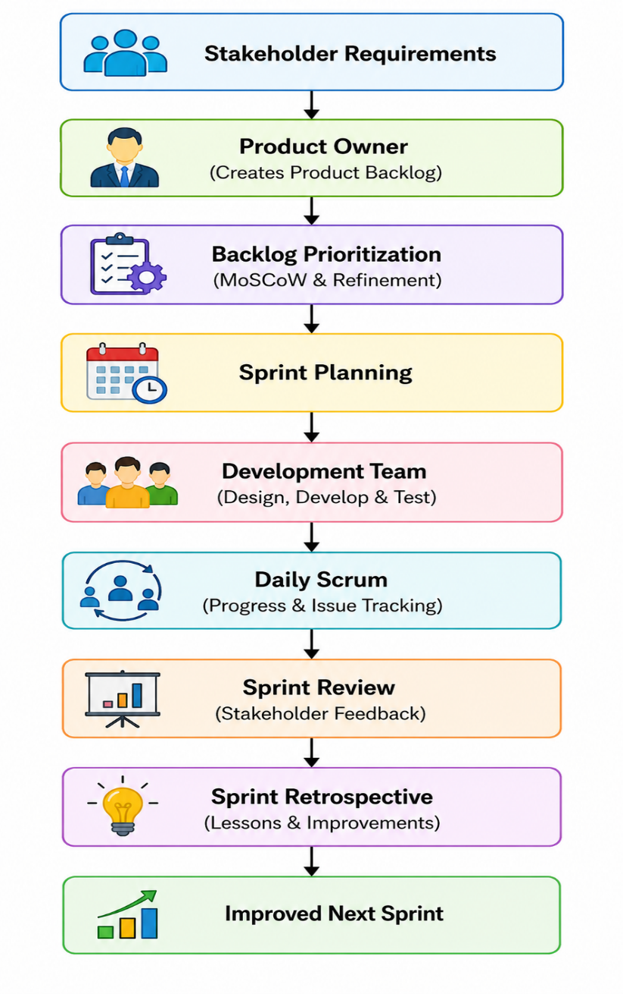

Real-World Example
A company is developing a Telemedicine App. During Sprint Planning, the Product Owner repeatedly changes feature priorities from Appointment Booking to Video Consultation and later to Online Payments. The development team cannot complete planned tasks, causing delays.
To solve this problem, the company:
- Prioritizes the Product Backlog using the MoSCoW method.
- Finalizes backlog items before Sprint Planning.
- Conducts regular backlog refinement meetings.
- Allows changes only in the next sprint.
- Uses Sprint Retrospectives to improve planning and communication.
This improves productivity, reduces requirement changes, and helps the team consistently achieve sprint goals.
Conclusion
Scrum enables Agile teams to develop software efficiently when roles and responsibilities are clearly followed. Frequent backlog changes reduce productivity and affect sprint success. By using proper backlog prioritization, regular backlog refinement, effective stakeholder communication, and continuous improvement through Sprint Retrospectives, the Telemedicine App project can deliver high-quality software on time while adapting to changing business needs.
